**Limited child care access across D.C. creates challenges for local parents**

By Annie Klingenberg, Jonathan Lehrfeld, Isabel Miller and Hannah Schoenbaum

WASHINGTON — Access to a seat in a child care center is limited for infants and toddlers across the District, and the high poverty rate in certain wards is making the situation worse.

Advocates, experts and local parents say the child care system in D.C. needs to change — and a previously underfunded piece of legislation in the District seeks to expand wages for child care workers and subsidies to afford care.

In total, the number of D.C. households with children under 6 years old is approximately 45,040, while the total number of seats in child care centers is 11,257, according to D.C. Kids Count, a nonprofit that provides District-wide and ward-level data on children and young adults.

For working parents, finding affordable and accessible child care is a necessity until their kids are old enough to be enrolled in public education. Regardless of income, parents across the District, however, are struggling to find convenient, high quality child care. In certain wards, the poverty level adds additional hurdles to affordable child care access.

“Even if you can afford it, you either cannot find it, or what you can find is poor quality … and you end up leaving your child somewhere that you don't feel 100% comfortable with, but it's all you can afford, and it's all that's available, and you've got to go to work,” said Simon Workman, co-founder of Prenatal to Five Fiscal, a non-profit that performs equity analyses on child care policies.

In 2008, D.C. passed the Pre-K Enhancement and Expansion Act, which was implemented in order to provide free, high quality preschool for all 3- and 4-year-olds in the District. Toddler and infant care still lack government funding.

**The “Birth to Three” Law**

In 2018, the D.C. Council also passed the “Birth to Three” Law, which would expand subsidies for infant and toddler care as well as increase wages for child care providers.

The council approved in July an amendment to the budget for fiscal year 2022 that would increase the income tax on the wealthiest 5% of individuals in the District to pay for the Birth to Three Law, which had never been fully funded.

Ruqiyyah Anbar-Shaheen, D.C. Action’s Director of Early Childhood and leader of the Under 3 D.C. Coalition, said the amendment would be the first step in putting the Birth to Three Law into practice.

“We have a workforce shortage, and we really need to address it in order to make more programs available and in order to start addressing some of these affordability issues,” Anbar-Shaheen said.

Access to early learning centers is not just inhibited by whether or not a family can afford it. It is also hindered by the lack of early learning educators who work within the city. Child care centers cannot provide quality learning, let alone open, without a sufficient workforce.

“It's hard to convince a recent college grad to go and be in child care, right, and make $12 an hour, even with a B.A.,” Workman said. “I think that's part of the issue is that even if you had the centers and had the money, right now, you still need the time to build up a pipeline of quality educators.”

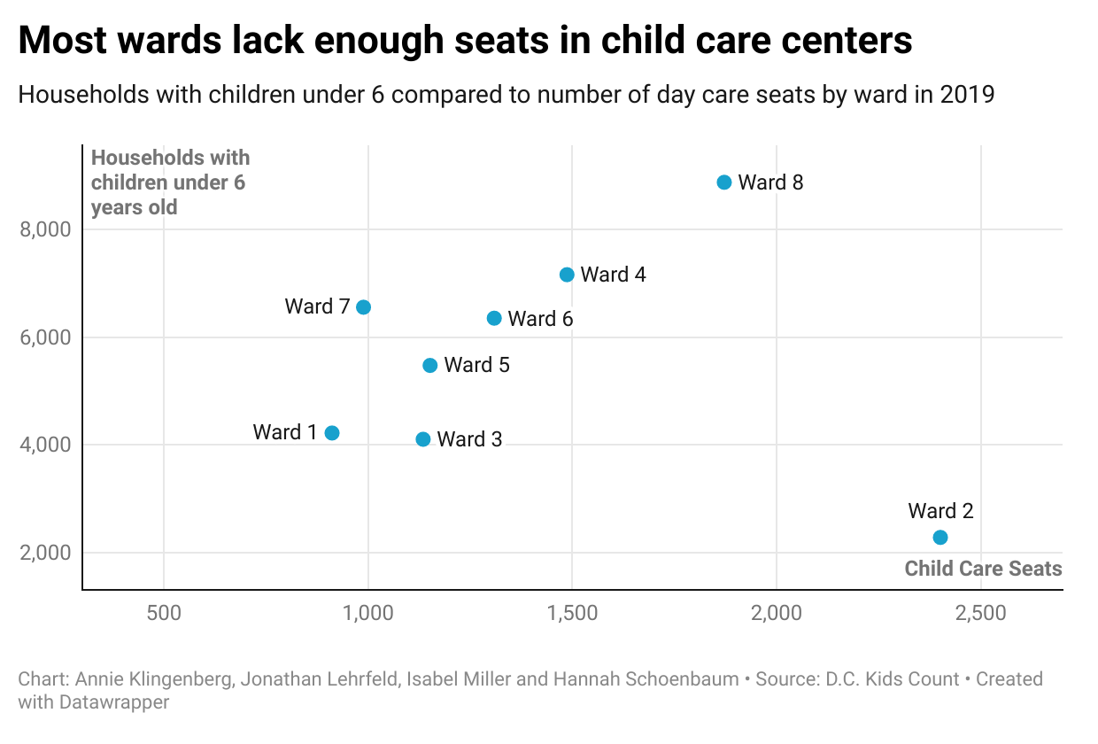

**District Spotlight**

Wards where children exceed the number of seats would each need an average of at least 4,223 more spots to accommodate the number of households with children under the age of 6, according to an analysis of 2019 census data accumulated by D.C. Kids Count.

In Ward 2, a working center in downtown D.C., which has the lowest population in the District of children under 6 years old, the number of child care center seats available is the highest. Ward 2 is the only ward in the District that has enough child care seats available to accommodate the population of children under 6 years old.

Ward 6 and Ward 7 are the two wards with the highest percent of children for every one seat available in a child care center. However, Ward 6 has a poverty rate of 9% for children under 5, while Ward 7 has a poverty rate of 40% for children under 5, according to 2019 census data accumulated by D.C. Kids Count. 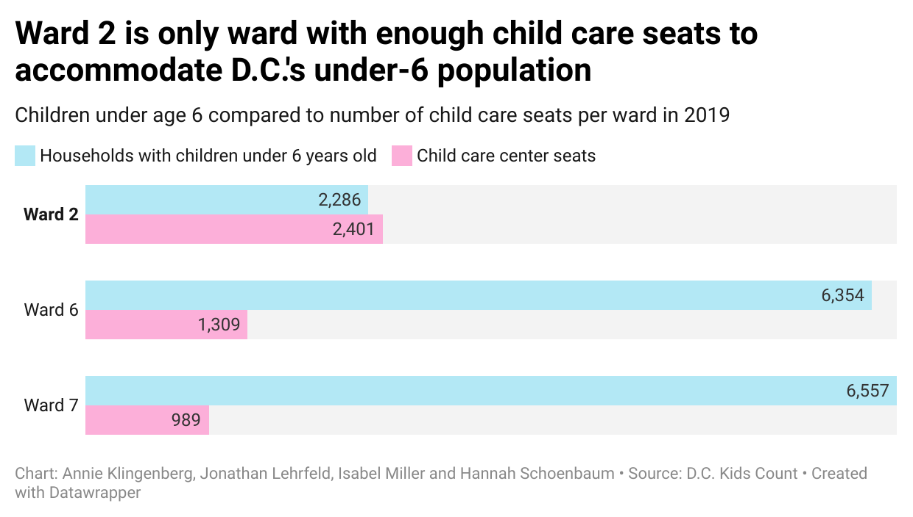

Despite the drastic difference in poverty levels between the two wards, both still severely lack in child care availability.

While there is a lack of access to child care regardless of income, poverty adds additional stressors for parents attempting to find child care. 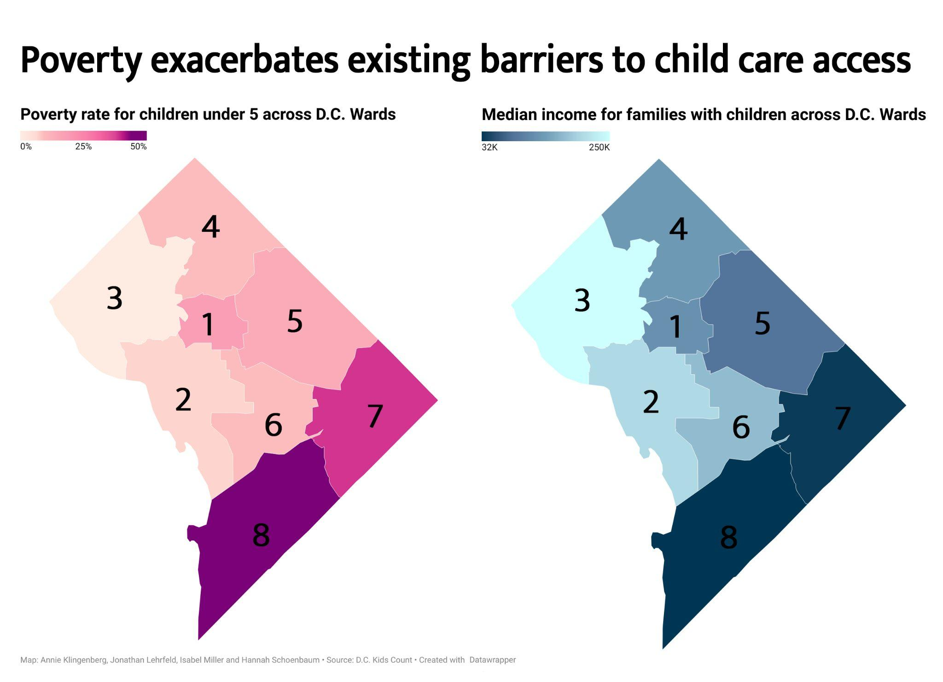

Jobs that pay at or below the poverty level often require working unusual hours or working weekends. Workman said child care is even more difficult to find during these off-hours.

“If you have a job that might call you up and be like, “Can you work these extra shifts?” … if you don't have reliable childcare, you can't do that,” Workman said.

D.C. has one of the [highest child care costs across the country](https://www.epi.org/child-care-costs-in-the-united-states/#/DC), according to the Economic Policy Institute, but the city is attempting to make strides in child care accessibility.

**A Necessity for Working Mothers**

Stephanie Cellini, a professor of public policy and economics at The George Washington University, said affordable, high quality child care is essential for women to be able to invest in their own higher education and job training.

Over a quarter of all undergraduate students are raising dependent children, according to the [Institute for Women’s Policy Research](https://iwpr.org/wp-content/uploads/2020/08/C424_Student-Parents_final-1.pdf). Of those 4.8 million students, 71% are mothers, and nearly half of those mothers are single parents.

“Access to affordable child care is essential for women to be able to invest in their own human capital,” Cellini said. “When you give women and, in particular, single mothers, child care subsidies, their enrollment in secondary education increases.”

Cellini, who is raising young children of her own in the District, said she knows a lot of parents who were unable to find seats for their children in child care centers or pre-kindergarten. Wealthier parents paid for private child care or nannies, while others left their jobs to take care of their kids.

“The dollars in early childhood education go far,” Cellini said. “It’s a cost-effective way to generate things like test score gains and graduation rate gains later in life. But, in D.C. especially, a lot of parents can’t afford to make that investment.”

Adena Kirstein, a parent who lives in Ward 4 with her 8-year-old, 6-year-old and 21-month-old children, has placed all of her kids in multiple child care centers across the city. Kirstein decided to put each of her kids on lists for child care centers before they were born, in response to the competitive nature of getting a seat.

The high cost is not all that makes finding an available seat challenging. Finding a seat near one’s home or place of employment is also a key factor.

Families who live in wards with fewer available child care seats often struggle to commute across the city to bring their children to centers in wards with more available seats.

“It was important for us, for a convenience factor, for us to be as close to home as possible,” Kirstein said. “The idea of adding an extra hour of commuting or less time with the kids never appealed to me. It was just never something I was going to consider.”

D.C. parents looking to strike the balance between child care accessibility and affordability must continue to navigate the complex system for the foreseeable future, until the Birth to Three Law is fully funded.

“If I struggle so much, and I have the money,” Kirstein said, “I’m not like rolling in it, but I have the money … I’m in a privileged place, and I can’t imagine how much harder it is for anyone else to navigate this.”

###

**Source List**

* Data Sources
  + Data set (link [HERE](https://docs.google.com/spreadsheets/d/1XGzIw8xlvS37g5F2vwNxEWGkCunq-tgMCs-6tZM_Zck/view#gid=1749512658)) from D.C. Action’s D.C. Kids Count, a nonprofit that provides District-wide and ward-level data on the district’s children and young adults.
    - Their data is compiled from census data & D.C. government data. Specifically they used info from:
      * Table B09001 for info on the number of kids in each D.C. ward
      * Tables B17001A-I for info on child poverty
      * Census Bureau Table S1903 for info on median household income in D.C. in each ward
      * DC Office of the State Superintendent of Education (OSSE) - [“Capacity Enrollment, Utilization” tables (Q16)](https://osse.dc.gov/page/fy19-performance-oversight-questions)
  + Data set (link [HERE](https://opendata.dc.gov/datasets/acs-economic-characteristics-dc-ward/explore?location=38.890543%2C-77.031102%2C11.56&showTable=true)) from Open Data D.C. on Economic Characteristics of DC Wards
  + Data set (link [HERE](https://opendata.dc.gov/datasets/DCGIS::child-development-centers/explore?location=38.903984%2C-76.969853%2C11.90)) from Open Data D.C. on Child Development Centers
    - This information was provided by the Office of the State Superintendent of Education.
  + Data set (link [HERE](https://opendata.dc.gov/datasets/acs-2018-median-household-income-variables-tract/explore?location=38.899487%2C-77.014578%2C11.67)) from Open Data D.C. on 2018 Median Household Income Variables Tract
* Interviews
  + Ruqiyyah Anbar-Shaheen, DC Action’s Director of Early Childhood and leader of the Under 3 DC Coalition,
    - [rabuanbar@dckids.org](mailto:rabuanbar@dckids.org)
    - 817-312-4896
  + Simon Workman, national expert on child care finance and co-founder of Prenatal to Five Fiscal
    - simonworkman@gmail.com
    - 720-934-0857
  + Stephanie Cellini, professor of public policy and economics at The George Washington University
    - cellini@gwu.edu
    - 202-536-2507
  + Adena Kirstein, D.C. parent, Executive Director of The George Washington University Hillel
    - [adena@gwhillel.org](mailto:adena@gwhillel.org)
    - (646) 221-7487